Can Gözpınar 68965
Engr421 Homework #5

Report

2.→ I read in the values using the numpy’s genfromtxt method. The data set file included x and y string values in its first row therefore, the genfromtxt method returned NaN for those values and I removed them using sub listing by removing the first row from the read in data set array. Then, I introduced two new variables namely, trainingDataSet which has the first 100 elements of the data set and testDataSet which has the remaining 33 elements of the data set.

3.- 4.→ Regression tree is constructed very much alike the classification tree. Most drastic change was that I changed the impurity function. I started with initializing the necessary parameters. First I set the P parameter to 15 since it was decided as that for this task. Then I had dictionary variables that are very much alike the one that we had in the lab this week for the decision tree classification with the exception of node_splits variable that keeps track of the x_positions our algorithm decides to split. We start by adding the root node and initializing its parameters. Then, we find nodes that need splitting and iterate over each one of them. At each iteration we check whether all of our nodes have become terminal node and if so then, it means our tree is complete so we break out of the outer while True loop. If that is not the case, that means we need to do splitting so we process as follows. We check for current node being terminal node. We do so by checking the number of elements that made it up to the current node. If the number of elements in our current node is less than or equal to P then we prune meaning we set that node as terminal node and do not split further which helps us not to over fit and decrease the computational complexity. If it is not the terminal node then, we decide on split positions. We decide on split positions by iterating over each possible split position and recording the impurity of each split then, from the recorded impurity values for each split we use it to choose the split as the split which yielded the smallest impurity value. The impurity function for splits is Em function that I have attached below which makes use of variance values given splits. We want to choose the split that minimizes the impurity since it would mean probable lower prediction error in the future. The gms value that is used in the impurity function is the mean of the y values in our training data set for the data that falls into the split that we are calculating over. After recording the split value, we proceed to split the node into left child node and the right child node. As a side node we use 2*n for the index of the left child’s node for a given root at index n and 2*n + 1 for the right child. We assign to left split the data points whose x values are lower than the decided split’s x value and right split gets the data points which made up to that node and has higher x values than the decided split’s x value. After the aforementioned process is over meaning that our tree is constructed with all the terminal nodes. For plotting I get the x values of the splits from the node_splits in a sorted and ascending order using some functions such as sorted() of python and combining it with lambda functions. This yields us the x_values which we will use to plot our fit while deciding on the split positions on the x axis. For finding the y_values we take the mean of the y values for the x values that lie to the corresponding positions given x_values for the splits using a for loop. Then all that was left was to draw the y_values with respect to the x_values which yielded me the fit. Important thing to note here was that I each split values were attained from the arithmetic mean of two adjacent x positions in our training data set.

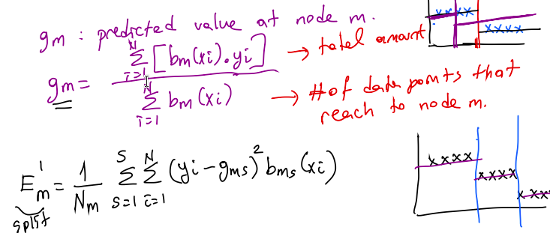

5.→ For calculating the RMSE, I used the y_values and x_values which correspond to the predicted y and x split locations that we’ve deducted from the training data set. I used two intertwined for loops to decide on where in which x split location the x value of the each data in the test data set lied and then recorded the corresponding predicted y value from the y_values that we had calculated earlier. Then I calculated the RMSE using the numpy’s sqrt and add functions to implement the RMSE formula given below.
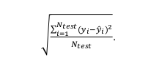

6.→ For learning decision trees given different P parameters I had to convert my decision tree code to a function which did nothing more than indenting the lines and putting a define indicator on top of the code which took P as a function parameter. Then I converted my rmse calculation code to a function the same way, by indenting the code block and adding a define which took extracted x_values and y_values as parameters that calling training decision tree algorithm returned. I also made use of global parameters which required me to define a initializeParameters function and call it before each call to training decision tree function namely, extractTreeInfo(P) funciton. This function reset the global parameters that I made use of by whenever I called the decision tree learning function so, by doing this I prevented using wrong leftover values from previous calls to this function.Then to calculate RMSE value for each p value I made use of the range function that returned me variables between 5 and 50 (50 inclusive) that incremented by constant 5. Using a for loop I iterated over each P value and calculated rmse values for the decision tree constructed for the given P value in each iteration of the for loop. In the for loop I recorded the RMSE values calculated for the given P value and recorded in an array which I initialized on top of the for loop, namely rmse_values array. Finally for plotting I made use of the pylot.plot function of matplotlib. I plotted two times since the first one drew the lines since I passed in “k” as parameter to the function and the other plotted the dots which I passed in “k.” to make it plot this way. Two calls to the plot() funciton had the same x and y values to plot from. Our x values were the P values and y values of the plot were the RMSE values that we had calculated and recorded in the rmse_values array which I made use of by, passing it as y values to the plot() function.

